CBTB SYSTEM DESIGN
- Class Diagram
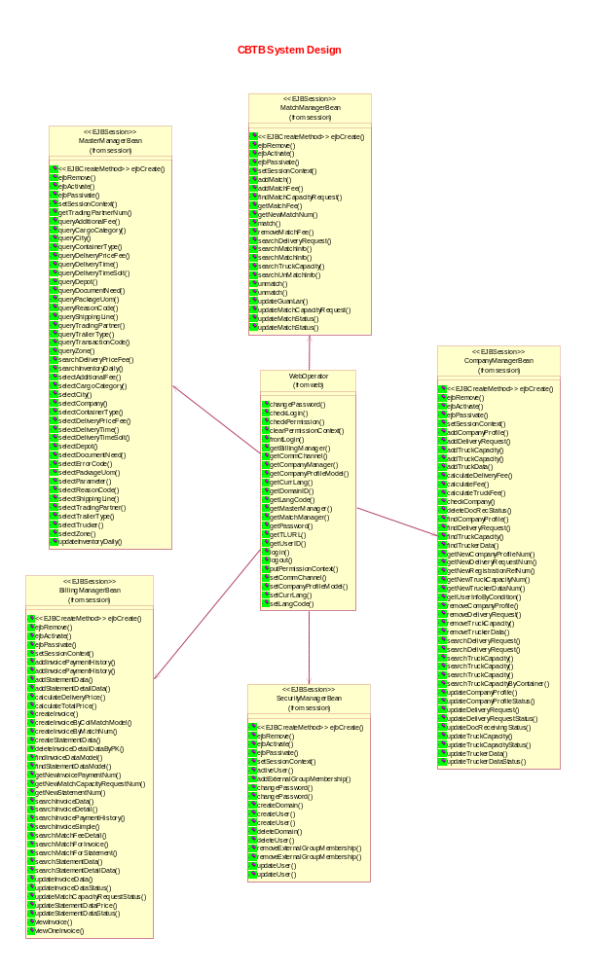
2.Package
com.cbtb.ejb.session
  - class com.cbtb.ejb.session.BillingManagerBean (implements javax.ejb.SessionBean)
  - class com.cbtb.ejb.session.CompanyManagerBean (implements javax.ejb.SessionBean)
  - class com.cbtb.ejb.session.MasterManagerBean (implements javax.ejb.SessionBean)
  - class com.cbtb.ejb.session.MatchManagerBean (implements javax.ejb.SessionBean)
  - class com.cbtb.ejb.session.SecurityManagerBean (implements javax.ejb.SessionBean)
  - interface javax.ejb.EJBHome
    - interface com.cbtb.ejb.session.BillingManagerHome
    - interface com.cbtb.ejb.session.CompanyManagerHome
    - interface com.cbtb.ejb.session.MasterManagerHome
    - interface com.cbtb.ejb.session.MatchManagerHome
    - interface com.cbtb.ejb.session.SecurityManagerHome
  - interface javax.ejb.EJBObject
    - interface com.cbtb.ejb.session.BillingManager
    - interface com.cbtb.ejb.session.CompanyManager(also extends java.io.Serializable)
    - interface com.cbtb.ejb.session.MasterManager
    - interface com.cbtb.ejb.session.MatchManager
    - interface com.cbtb.ejb.session.SecurityManager
com.cbtb.ejb.entity
  - class com.cbtb.ejb.entity.AdditionalFeeBean (implements javax.ejb.EntityBean)
    - class com.cbtb.ejb.entity.AdditionalFeeBeanBMP
  - class com.cbtb.ejb.entity.AdditionalFeeValue (implements java.io.Serializable)
  - class com.cbtb.ejb.entity.CargoCategoryBean (implements javax.ejb.EntityBean)
    - class com.cbtb.ejb.entity.CargoCategoryBeanBMP
  - class com.cbtb.ejb.entity.CargoCategoryValue (implements java.io.Serializable)
  - class com.cbtb.ejb.entity.CityDataBean (implements javax.ejb.EntityBean)
    - class com.cbtb.ejb.entity.CityDataBeanBMP
  - class com.cbtb.ejb.entity.CityDataValue (implements java.io.Serializable)
  - class com.cbtb.ejb.entity.CompanyProfileBean (implements javax.ejb.EntityBean)
    - class com.cbtb.ejb.entity.CompanyProfileBeanBMP
  - class com.cbtb.ejb.entity.ContainerTypeBean (implements javax.ejb.EntityBean)
    - class com.cbtb.ejb.entity.ContainerTypeBeanBMP
  - class com.cbtb.ejb.entity.ContainerTypePK (implements java.io.Serializable)
  - class com.cbtb.ejb.entity.ContainerTypeValue (implements java.io.Serializable)
  - class com.cbtb.ejb.entity.DeliveryPriceFeeBean (implements javax.ejb.EntityBean)
    - class com.cbtb.ejb.entity.DeliveryPriceFeeBeanBMP
  - class com.cbtb.ejb.entity.DeliveryPriceFeePK (implements java.io.Serializable)
  - class com.cbtb.ejb.entity.DeliveryPriceFeeValue (implements java.io.Serializable)
  - class com.cbtb.ejb.entity.DeliveryRequestBean (implements javax.ejb.EntityBean)
    - class com.cbtb.ejb.entity.DeliveryRequestBeanBMP
  - class com.cbtb.ejb.entity.DeliveryTimeBean (implements javax.ejb.EntityBean)
    - class com.cbtb.ejb.entity.DeliveryTimeBeanBMP
  - class com.cbtb.ejb.entity.DeliveryTimeSlotBean (implements javax.ejb.EntityBean)
    - class com.cbtb.ejb.entity.DeliveryTimeSlotBeanBMP
  - class com.cbtb.ejb.entity.DeliveryTimeSlotValue (implements java.io.Serializable)
  - class com.cbtb.ejb.entity.DeliveryTimeValue (implements java.io.Serializable)
  - class com.cbtb.ejb.entity.DepotBean (implements javax.ejb.EntityBean)
    - class com.cbtb.ejb.entity.DepotBeanBMP
  - class com.cbtb.ejb.entity.DepotValue (implements java.io.Serializable)
  - class com.cbtb.ejb.entity.DocumentNeedBean (implements javax.ejb.EntityBean)
    - class com.cbtb.ejb.entity.DocumentNeedBeanBMP
  - class com.cbtb.ejb.entity.DocumentNeedValue (implements java.io.Serializable)
  - class com.cbtb.ejb.entity.DocumentReceivingStatusBean (implements javax.ejb.EntityBean)
    - class com.cbtb.ejb.entity.DocumentReceivingStatusBeanBMP
  - class com.cbtb.ejb.entity.DocumentReceivingStatusPK (implements java.io.Serializable)
  - class com.cbtb.ejb.entity.InventoryDailyBean (implements javax.ejb.EntityBean)
    - class com.cbtb.ejb.entity.InventoryDailyBeanBMP
  - class com.cbtb.ejb.entity.InventoryDailyPK (implements java.io.Serializable)
  - class com.cbtb.ejb.entity.InvoiceDataBean (implements javax.ejb.EntityBean)
    - class com.cbtb.ejb.entity.InvoiceDataBeanBMP
  - class com.cbtb.ejb.entity.InvoiceDetailDataBean (implements javax.ejb.EntityBean)
    - class com.cbtb.ejb.entity.InvoiceDetailDataBeanBMP
  - class com.cbtb.ejb.entity.InvoiceDetailDataPK (implements java.io.Serializable)
  - class com.cbtb.ejb.entity.InvoicePaymentHistoryBean (implements javax.ejb.EntityBean)
    - class com.cbtb.ejb.entity.InvoicePaymentHistoryBeanBMP
  - class com.cbtb.ejb.entity.InvoicePaymentHistoryPK (implements java.io.Serializable)
  - class com.cbtb.ejb.entity.MatchCapacityRequestBean (implements javax.ejb.EntityBean)
    - class com.cbtb.ejb.entity.MatchCapacityRequestBeanBMP
  - class com.cbtb.ejb.entity.MatchFeeDetailBean (implements javax.ejb.EntityBean)
    - class com.cbtb.ejb.entity.MatchFeeDetailBeanBMP
  - class com.cbtb.ejb.entity.MatchFeeDetailPK (implements java.io.Serializable)
  - class com.cbtb.ejb.entity.PackageUomBean (implements javax.ejb.EntityBean)
    - class com.cbtb.ejb.entity.PackageUomBeanBMP
  - class com.cbtb.ejb.entity.PackageUomValue (implements java.io.Serializable)
  - class com.cbtb.ejb.entity.ReasonCodeBean (implements javax.ejb.EntityBean)
    - class com.cbtb.ejb.entity.ReasonCodeBeanBMP
  - class com.cbtb.ejb.entity.ReasonCodeValue (implements java.io.Serializable)
  - class com.cbtb.ejb.entity.ShippingLineBean (implements javax.ejb.EntityBean)
    - class com.cbtb.ejb.entity.ShippingLineBeanBMP
  - class com.cbtb.ejb.entity.ShippingLineValue (implements java.io.Serializable)
  - class com.cbtb.ejb.entity.StatementDataBean (implements javax.ejb.EntityBean)
    - class com.cbtb.ejb.entity.StatementDataBeanBMP
  - class com.cbtb.ejb.entity.StatementDetailDataBean (implements javax.ejb.EntityBean)
    - class com.cbtb.ejb.entity.StatementDetailDataBeanBMP
  - class com.cbtb.ejb.entity.StatementDetailDataPK (implements java.io.Serializable)
  - class com.cbtb.ejb.entity.SystemProcessParameterBean (implements javax.ejb.EntityBean)
    - class com.cbtb.ejb.entity.SystemProcessParameterBeanBMP
  - class com.cbtb.ejb.entity.SystemProcessParameterValue (implements java.io.Serializable)
  - class com.cbtb.ejb.entity.TradingPartnerBean (implements javax.ejb.EntityBean)
    - class com.cbtb.ejb.entity.TradingPartnerBeanBMP
  - class com.cbtb.ejb.entity.TradingPartnerValue (implements java.io.Serializable)
  - class com.cbtb.ejb.entity.TrailerTypeBean (implements javax.ejb.EntityBean)
    - class com.cbtb.ejb.entity.TrailerTypeBeanBMP
  - class com.cbtb.ejb.entity.TrailerTypeValue (implements java.io.Serializable)
  - class com.cbtb.ejb.entity.TransactionCodeBean (implements javax.ejb.EntityBean)
    - class com.cbtb.ejb.entity.TransactionCodeBeanBMP
  - class com.cbtb.ejb.entity.TransactionCodeValue (implements java.io.Serializable)
  - class com.cbtb.ejb.entity.TransactionLogBean (implements javax.ejb.EntityBean)
    - class com.cbtb.ejb.entity.TransactionLogBeanBMP
  - class com.cbtb.ejb.entity.TransactionLogPK (implements java.io.Serializable)
  - class com.cbtb.ejb.entity.TruckCapacityBean (implements javax.ejb.EntityBean)
    - class com.cbtb.ejb.entity.TruckCapacityBeanBMP
  - class com.cbtb.ejb.entity.TruckerDataBean (implements javax.ejb.EntityBean)
    - class com.cbtb.ejb.entity.TruckerDataBeanBMP
  - class com.cbtb.ejb.entity.ZoneBean (implements javax.ejb.EntityBean)
    - class com.cbtb.ejb.entity.ZoneBeanBMP
  - class com.cbtb.ejb.entity.ZoneValue (implements java.io.Serializable)
  - interface javax.ejb.EJBHome
    - interface com.cbtb.ejb.entity.AdditionalFeeHome
    - interface com.cbtb.ejb.entity.CargoCategoryHome
    - interface com.cbtb.ejb.entity.CityDataHome
    - interface com.cbtb.ejb.entity.CompanyProfileHome
    - interface com.cbtb.ejb.entity.ContainerTypeHome
    - interface com.cbtb.ejb.entity.DeliveryPriceFeeHome
    - interface com.cbtb.ejb.entity.DeliveryRequestHome
    - interface com.cbtb.ejb.entity.DeliveryTimeHome
    - interface com.cbtb.ejb.entity.DeliveryTimeSlotHome
    - interface com.cbtb.ejb.entity.DepotHome
    - interface com.cbtb.ejb.entity.DocumentNeedHome
    - interface com.cbtb.ejb.entity.DocumentReceivingStatusHome
    - interface com.cbtb.ejb.entity.InventoryDailyHome
    - interface com.cbtb.ejb.entity.InvoiceDataHome
    - interface com.cbtb.ejb.entity.InvoiceDetailDataHome
    - interface com.cbtb.ejb.entity.InvoicePaymentHistoryHome
    - interface com.cbtb.ejb.entity.MatchCapacityRequestHome
    - interface com.cbtb.ejb.entity.MatchFeeDetailHome
    - interface com.cbtb.ejb.entity.PackageUomHome
    - interface com.cbtb.ejb.entity.ReasonCodeHome
    - interface com.cbtb.ejb.entity.ShippingLineHome
    - interface com.cbtb.ejb.entity.StatementDataHome
    - interface com.cbtb.ejb.entity.StatementDetailDataHome
    - interface com.cbtb.ejb.entity.SystemProcessParameterHome
    - interface com.cbtb.ejb.entity.TradingPartnerHome
    - interface com.cbtb.ejb.entity.TrailerTypeHome
    - interface com.cbtb.ejb.entity.TransactionCodeHome
    - interface com.cbtb.ejb.entity.TransactionLogHome
    - interface com.cbtb.ejb.entity.TruckCapacityHome
    - interface com.cbtb.ejb.entity.TruckerDataHome
    - interface com.cbtb.ejb.entity.ZoneHome
  - interface javax.ejb.EJBObject
    - interface com.cbtb.ejb.entity.AdditionalFee
    - interface com.cbtb.ejb.entity.CargoCategory
    - interface com.cbtb.ejb.entity.CityData
    - interface com.cbtb.ejb.entity.CompanyProfile
    - interface com.cbtb.ejb.entity.ContainerType
    - interface com.cbtb.ejb.entity.DeliveryPriceFee
    - interface com.cbtb.ejb.entity.DeliveryRequest
    - interface com.cbtb.ejb.entity.DeliveryTime
    - interface com.cbtb.ejb.entity.DeliveryTimeSlot
    - interface com.cbtb.ejb.entity.Depot
    - interface com.cbtb.ejb.entity.DocumentNeed
    - interface com.cbtb.ejb.entity.DocumentReceivingStatus
    - interface com.cbtb.ejb.entity.InventoryDaily
    - interface com.cbtb.ejb.entity.InvoiceData
    - interface com.cbtb.ejb.entity.InvoiceDetailData
    - interface com.cbtb.ejb.entity.InvoicePaymentHistory
    - interface com.cbtb.ejb.entity.MatchCapacityRequest
    - interface com.cbtb.ejb.entity.MatchFeeDetail
    - interface com.cbtb.ejb.entity.PackageUom
    - interface com.cbtb.ejb.entity.ReasonCode
    - interface com.cbtb.ejb.entity.ShippingLine
    - interface com.cbtb.ejb.entity.StatementData
    - interface com.cbtb.ejb.entity.StatementDetailData
    - interface com.cbtb.ejb.entity.SystemProcessParameter
    - interface com.cbtb.ejb.entity.TradingPartner
    - interface com.cbtb.ejb.entity.TrailerType
    - interface com.cbtb.ejb.entity.TransactionCode
    - interface com.cbtb.ejb.entity.TransactionLog
    - interface com.cbtb.ejb.entity.TruckCapacity
    - interface com.cbtb.ejb.entity.TruckerData
    - interface com.cbtb.ejb.entity.Zone

com.cbtb. exception
          - class com.cbtb.exception.CbtbException (implements java.io.Serializable)
com.cbtb. model
  - class com.cbtb.model.CityDataModel (implements java.io.Serializable)
  - class com.cbtb.model.CityZoneModel (implements java.io.Serializable)
  - class com.cbtb.model.CompanyProfileModel (implements java.io.Serializable)
  - class com.cbtb.model.ContainerTypeTrailerModel (implements java.io.Serializable)
  - class com.cbtb.model.DeliveryPriceFeeModel (implements java.io.Serializable)
  - class com.cbtb.model.DeliveryRequestModel (implements java.io.Serializable)
  - class com.cbtb.model.DeliveryTimeModel (implements java.io.Serializable)
  - class com.cbtb.model.DepotDataModel (implements java.io.Serializable)
  - class com.cbtb.model.DocRecStatusModel (implements java.io.Serializable)
  - class com.cbtb.model.ErrorCodeModel (implements java.io.Serializable)
  - class com.cbtb.model.InventoryDailyModel (implements java.io.Serializable)
  - class com.cbtb.model.InvoiceDataModel (implements java.io.Serializable)
  - class com.cbtb.model.InvoiceDetailDataModel (implements java.io.Serializable)
  - class com.cbtb.model.InvoicePaymentHistoryModel (implements java.io.Serializable)
  - class com.cbtb.model.MatchFeeDetailModel (implements java.io.Serializable)
  - class com.cbtb.model.MatchModel (implements java.io.Serializable)
  - class com.cbtb.model.StatementDataModel (implements java.io.Serializable)
  - class com.cbtb.model.StatementDetailDataModel (implements java.io.Serializable)
  - class com.cbtb.model.TransactionCodeModel (implements java.io.Serializable)
  - class com.cbtb.model.TransFormat
  - class com.cbtb.model.TruckCapacityModel (implements java.io.Serializable)
  - class com.cbtb.model.TruckerDataModel (implements java.io.Serializable)
  - class com.cbtb.model.TruckMatchModel (implements java.io.Serializable)
  - class com.cbtb.model.ZoneDataModel (implements java.io.Serializable)
com.cbtb.web
  - class com.cbtb.web. CbtbErrorContext
  - class com.cbtb.web. DbList.java
  - class com.cbtb.web.WebOperator
  - class com.cbtb.web.MatchStatus
com.cbtb.util
  - class com.cbtb.util.CbtbConstant
  - class com.cbtb.util.Debug
  - class com.cbtb.util.EjbUtil
  - class com.cbtb.util.NewPagination
  - class com.cbtb.util.NumberConvertText
  - class com.cbtb.util.Pagination
  - class com.cbtb.util.UtilTool
com.cbtb. javabea
  - class com.cbtb.javabean.AddFeeJB (implements java.io.Serializable)
  - class com.cbtb.javabean.CargoCategoryJB
  - class com.cbtb.javabean.CityJB (implements java.io.Serializable)
  - class com.cbtb.javabean.ContainerTypeJB (implements java.io.Serializable)
  - class com.cbtb.javabean.DeliveryPriceFeeJB (implements java.io.Serializable)
  - class com.cbtb.javabean.DeliveryTimeJB
  - class com.cbtb.javabean.DeliveryTimeSlotJB
  - class com.cbtb.javabean.DepotJB
  - class com.cbtb.javabean.DocumentNeedJB (implements java.io.Serializable)
  - class com.cbtb.javabean.PackageUomJB (implements java.io.Serializable)
  - class com.cbtb.javabean.ReasonCodeJB (implements java.io.Serializable)
  - class com.cbtb.javabean.ShippingLineJB
  - class com.cbtb.javabean.SystemParameterJB
  - class com.cbtb.javabean.TradingPartnerJB
  - class com.cbtb.javabean.TrailerTypeJB
  - class com.cbtb.javabean.TransactionCodeJB
  - class com.cbtb.javabean.ZoneJB

3.Method
com.cbtb.ejb.session
- BillingManager
public Collection searchMatchForStatement(String companyId,String matchNum,
String beginDate,String endDate,String status,String orderByName)
throws RemoteException;
public String getNewMatchCapacityRequestNum() throws RemoteException;
public boolean updateMatchCapacityRequestStatus(String matchNum,String status)
throws RemoteException;
public StatementData addStatementData(String truckCompanyNo, String statementNo,
String statementAddr1, String statementAddr2, String statementAddr3,
String statementAddr4, String contactPerson, String contactChinesePerson,
BigDecimal totalPrice, Timestamp fromDate, Timestamp toDate,
String statementStatus, String payStatus, String totalFullText,
Timestamp creationDate) throws RemoteException;
public StatementDetailData addStatementDetailData(String statementNo,
String matchNumber, String truckCapacityNum, String containerTypeId,
String originCity, String destinationCity, Timestamp deliveryDate,
BigDecimal deliveryPrice) throws RemoteException;
public boolean addStatementData(StatementDataModel sdm)
throws RemoteException;
public boolean addStatementDetailData(StatementDetailDataModel sddm)
throws RemoteException;
public Collection createStatementData(String companyId,String matchNum,String beginDate,String endDate)
throws RemoteException;
public BigDecimal calculateDeliveryPrice(String matchNumber) throws RemoteException;
public BigDecimal calculateTotalPrice(String statementNo) throws RemoteException;
public StatementDataModel findStatementDataModel(String statementNo) throws RemoteException;
public String getNewStatementNum() throws RemoteException;
public Collection searchStatementDetailData(String statementNo) throws RemoteException;
public Collection searchStatementData(String companyId,String statementNo,String beginDate,String endDate,String status) throws RemoteException;
public boolean updateStatementDataPrice(java.lang.String statementNo, java.math.BigDecimal totalPrice)
throws RemoteException;
public Collection searchMatchFeeDetail(String matchNumber) throws RemoteException;
public Collection createInvoice(String companyId,String matchNum,
String beginDate,String endDate) throws RemoteException;
public Collection createInvoiceByColMatchModel(Collection colMatchModel,String fromDate,String toDate)
throws RemoteException;
public Collection createInvoiceByMatchNum(Collection colMatchNum,String fromDate,String toDate)
throws RemoteException;

public boolean deleteInvoiceDetailDataByPK(InvoiceDetailDataPK pk) throws RemoteException;
public Collection searchInvoiceSimple(String shipperNo,String invoiceNo,String beginInvoiceCreateDate,String endInvoiceCreateDate,Vector invoiceStatus) throws RemoteException,CbtbException;
public Collection searchInvoiceDetail(String shipperNo,String invoiceNo,String beginInvoiceCreateDate,
String endInvoiceCreateDate,Vector invoiceStatus) throws RemoteException,CbtbException;
public Collection searchMatchForInvoice(String companyId,Vector matchNum,String beginDate,String endDate,
Vector matchStatus,String orderByName) throws RemoteException;
public boolean updateInvoiceDataStatus(String invoiceNo,String status) throws RemoteException,CbtbException;
public boolean updateInvoiceData(InvoiceDataModel idm) throws RemoteException;
public InvoiceDataModel viewOneInvoice(String invoiceNo) throws RemoteException,CbtbException;
public Collection viewInvoice(Vector vctInvoiceNo) throws RemoteException,CbtbException;
public java.lang.String getNewInvoicePaymentNum() throws SQLException, RemoteException;
public java.util.Collection searchInvoicePaymentHistory(java.lang.String invoiceNo) throws RemoteException;
public java.util.Collection searchInvoiceData(java.lang.String shipperNo, java.lang.String invoiceNo,
java.lang.String creationDate, java.lang.String invoiceStatus, java.lang.String orderByName)
throws RemoteException;
public boolean addInvoicePaymentHistory(java.lang.String invoiceNo, java.sql.Timestamp paymentDate,
java.lang.String paidBy, java.lang.String ref, java.math.BigDecimal payAmount) throws CbtbException,
Exception, RemoteException;
public boolean addInvoicePaymentHistory(java.lang.String invoiceNo, java.lang.String paymentDate,
java.lang.String paidBy, java.lang.String ref, java.lang.String payAmount) throws CbtbException,
Exception, RemoteException;
public boolean updateStatementDataStatus(java.lang.String statementNo, java.lang.String status) throws CbtbException, RemoteException;
public com.cbtb.model.InvoiceDataModel findInvoiceDataModel(java.lang.String invoiceNo) throws RemoteException;

- CompanyManager
public java.lang.String getNewDeliveryRequestNum() throws RemoteException;
public java.lang.String getName() throws RemoteException;
public com.cbtb.model.DeliveryRequestModel findDeliveryRequest(java.lang.String deliveryRequestNum)
throws RemoteException;
public boolean updateDeliveryRequestStatus(java.lang.String deliveryRequestNum, java.lang.String status)
throws RemoteException;
public String getNewTruckCapacityNum() throws RemoteException;
public java.util.Collection searchTruckCapacity(java.lang.String truckCapacityNum, java.lang.String originZoneId, java.lang.String companyId, java.lang.String originCityId, java.lang.String destinationCityId, java.lang.String deliveryDate, java.lang.String deliveryTimeId, java.lang.String deliveryTimeSlot, java.lang.String trailerId, java.lang.String matchNumber, java.lang.String destinationZoneId, java.lang.String truckCapacityStatus, java.lang.String orderByName) throws RemoteException;
public com.cbtb.model.TruckCapacityModel findTruckCapacity(java.lang.String truckCapacityNum)
throws RemoteException;
public boolean removeTruckCapacity(java.lang.String truckCapacityNum) throws RemoteException;
public boolean updateTruckCapacityStatus(java.lang.String truckCapacityNum, java.lang.String status)
throws RemoteException;
public boolean checkCompany(java.lang.String companyId) throws RemoteException;
public java.util.Collection searchDeliveryRequest(java.lang.String companyId, java.lang.String matchNumber, java.lang.String originZoneId, java.lang.String originCityId, java.lang.String destinationZoneId, java.lang.String destinationCityId, java.lang.String requestStatus, java.lang.String containerTypeId, java.lang.String deliveryDate, java.lang.String deliveryRequestNum, java.lang.String deliveryTime, java.lang.String timeSlotId, java.lang.String shippingOrderNo, java.lang.String orderByName) throws RemoteException;

public boolean removeCompanyProfile(String companyId) throws RemoteException;
public boolean addCompanyProfile(CompanyProfileModel cpm) throws CbtbException,RemoteException;
public String getNewRegistrationRefNum() throws RemoteException;
public String getNewCompanyProfileNum() throws RemoteException;
public CompanyProfileModel findCompanyProfile(String companyId) throws RemoteException;
public boolean updateCompanyProfileStatus(String companyId, String status) throws RemoteException;
public boolean removeTruckerData(String truckerId) throws RemoteException;
public TruckerData addTruckerData(String companyId, String truckerId,
String truckerName, String truckerChineseName, String hkId,
String truckerAddr1, String truckerAddr2, String truckerAddr3,
String truckerAddr4, String hkTelephoneNo, String hkMobileNo,
String hkPagerNo, String inlandTelephoneNo, String inlandMobileNo,
String inlandPagerNo, String hkLicenseNo, String inlandLicenseNo,
String hkPlateNo, String inlandPlateNo, String truckModelNo,
String truckColor, String carryWeight, String remark, String truckStatus,
String reasonId, Timestamp creationDate) throws RemoteException;
public boolean addTruckerData(TruckerDataModel tdm) throws RemoteException;
public String getNewTruckerDataNum() throws RemoteException;
public TruckerDataModel findTruckerData(String truckerId) throws RemoteException;
public boolean updateTruckerDataStatus(String truckerId, String status) throws RemoteException;
public java.math.BigDecimal calculateDeliveryFee(java.lang.String containerTypeId, java.lang.String originCityId, java.lang.String destinationCityId) throws RemoteException;
public java.util.Collection searchDeliveryRequest(java.lang.String companyId) throws RemoteException;
public java.util.Collection searchTruckCapacity(java.lang.String companyId) throws RemoteException;
public java.math.BigDecimal calculateTruckFee(java.lang.String trailerId, java.lang.String originCityId, java.lang.String destinationCityId) throws RemoteException;
public java.math.BigDecimal calculateFee(java.lang.String containerTypeId, java.lang.String cityId, boolean isIB,
boolean isShipper) throws RemoteException;
public java.util.Collection searchTruckCapacity(java.lang.String truckerId, java.lang.String companyId)
throws RemoteException;
public java.util.Collection getUserInfoByCondition(java.lang.String companyId, java.lang.String companyName, java.lang.String contactPerson, java.lang.String telephoneNo, java.lang.String faxNo, java.lang.String HKMobileNo, java.lang.String truckerName, java.lang.String HKPlateNo, java.lang.String selectType, java.lang.String refNum, java.lang.String HKLicenseNo,java.lang.String truckerId, java.lang.String orderBy) throws RemoteException;
public boolean addDeliveryRequest(com.cbtb.model.DeliveryRequestModel drm) throws CbtbException, RemoteException;
public boolean updateDeliveryRequest(com.cbtb.model.DeliveryRequestModel drm)
throws CbtbException, RemoteException;
public boolean updateTruckCapacity(com.cbtb.model.TruckCapacityModel tcm) throws CbtbException, RemoteException;
public boolean addTruckCapacity(java.util.Collection truckCapacitys) throws CbtbException, RemoteException;
public boolean addTruckCapacity(com.cbtb.model.TruckCapacityModel tcm) throws CbtbException, RemoteException;
public boolean updateCompanyProfile(com.cbtb.model.CompanyProfileModel cpm)
throws CbtbException, RemoteException;
public boolean updateTruckerData(com.cbtb.model.TruckerDataModel tdm) throws CbtbException, RemoteException;
public boolean removeDeliveryRequest(java.lang.String deliveryRequestNum) throws CbtbException, RemoteException;
public boolean deleteDocRecStatus(com.cbtb.model.DocRecStatusModel drsm) throws RemoteException;
public boolean updateDocReceivingStatus(com.cbtb.model.DocRecStatusModel drsm) throws RemoteException;
public java.util.Collection searchTruckCapacityByContainer(java.lang.String truckCapacityNum, java.lang.String originZoneId, java.lang.String companyId, java.lang.String originCityId, java.lang.String destinationCityId, java.lang.String deliveryDate, java.lang.String deliveryTimeId, java.lang.String deliveryTimeSlot, java.lang.String containerTypeId, java.lang.String matchNumber, java.lang.String destinationZoneId, java.lang.String truckCapacityStatus, java.lang.String orderByName) throws RemoteException;

- MasterManager
public ArrayList selectCity() throws java.rmi.RemoteException ,FinderException;
public Collection queryCity(String sqlString) throws java.rmi.RemoteException ,FinderException;
public ArrayList selectZone() throws java.rmi.RemoteException ,FinderException;
public Collection queryZone(String sqlString) throws java.rmi.RemoteException ,FinderException;
public ArrayList selectContainerType() throws java.rmi.RemoteException ,FinderException;
public ArrayList selectShippingLine() throws java.rmi.RemoteException ,FinderException;
public ArrayList selectTransactionCode() throws java.rmi.RemoteException ,FinderException;
public Collection queryContainerType(String sqlString) throws java.rmi.RemoteException ,FinderException;
public Collection queryShippingLine(String sqlString) throws java.rmi.RemoteException ,FinderException;
public Collection queryTransactionCode(String sqlString) throws java.rmi.RemoteException ,FinderException;
public ArrayList selectPackageUom() throws java.rmi.RemoteException ,FinderException;
public Collection queryPackageUom(String sqlString) throws java.rmi.RemoteException ,FinderException;
public ArrayList selectReasonCode() throws java.rmi.RemoteException ,FinderException;
public Collection queryReasonCode(String sqlString) throws java.rmi.RemoteException ,FinderException;
public ArrayList selectDocumentNeed() throws java.rmi.RemoteException ,FinderException;
public Collection queryDocumentNeed(String sqlString) throws java.rmi.RemoteException ,FinderException;
public ArrayList selectDeliveryTime() throws java.rmi.RemoteException ,FinderException;
public Collection queryDeliveryTime(String sqlString) throws java.rmi.RemoteException ,FinderException;
public ArrayList selectDeliveryTimeSolt() throws java.rmi.RemoteException ,FinderException;
public Collection queryDeliveryTimeSolt(String sqlString) throws java.rmi.RemoteException ,FinderException;
public ArrayList selectTrailerType() throws java.rmi.RemoteException ,FinderException;
public ArrayList selectCargoCategory() throws java.rmi.RemoteException ,FinderException;
public ArrayList selectDepot() throws java.rmi.RemoteException ,FinderException;
public Collection queryCargoCategory(String sqlString) throws java.rmi.RemoteException ,FinderException;
public Collection queryTrailerType(String sqlString) throws java.rmi.RemoteException ,FinderException;
public Collection queryDepot(String sqlString) throws java.rmi.RemoteException ,FinderException;
public Collection queryAdditionalFee (String sqlString)throws java.rmi.RemoteException ,FinderException;
public ArrayList selectAdditionalFee() throws java.rmi.RemoteException ,FinderException;
public ArrayList selectDeliveryPriceFee() throws java.rmi.RemoteException ,FinderException;
public Collection queryDeliveryPriceFee(String sqlString) throws java.rmi.RemoteException ,FinderException;
public ArrayList selectParameter() throws java.rmi.RemoteException ,FinderException;
public java.util.Collection queryTradingPartner(java.lang.String sqlString)
throws java.rmi.RemoteException, FinderException, RemoteException;
public java.util.ArrayList selectTradingPartner() throws java.rmi.RemoteException, FinderException, RemoteException;
public java.util.Collection selectCompany() throws java.rmi.RemoteException, FinderException, RemoteException;
public java.util.Collection selectTrucker() throws java.rmi.RemoteException, FinderException, RemoteException;
public java.util.Collection selectErrorCode() throws RemoteException;
public void throwExceptionTest() throws CbtbException, RemoteException;
public java.util.Collection searchInventoryDaily(java.lang.String depotId, java.lang.String shippingLineId, java.lang.String containerTypeId, java.lang.String captureDate) throws CbtbException, RemoteException;
public boolean updateInventoryDaily(java.util.Collection inventoryDailyList) throws CbtbException, RemoteException;
public java.util.Collection searchDeliveryPriceFee(java.lang.String containerTypeId,
java.lang.String cityId, java.lang.String zoneId) throws RemoteException;
public java.lang.String getTradingPartnerNum() throws RemoteException;

- MatchManager
public com.cbtb.model.MatchModel match(java.lang.String deliveryRequestNum, java.lang.String truckCapacityNum) throws RemoteException, CbtbException;
public boolean removeMatchFee(java.util.Collection matchFeeList) throws CbtbException, RemoteException;
public boolean addMatchFee(com.cbtb.model.MatchFeeDetailModel mfdm) throws CbtbException, RemoteException;
public java.util.Collection getMatchFee(java.lang.String matchNumber) throws RemoteException;
public com.cbtb.model.MatchModel findMatchCapacityRequest(java.lang.String matchNumber) throws RemoteException;
public java.util.Collection searchTruckCapacity(java.lang.String truckCapacityNum, java.lang.String companyName, java.lang.String originCityId, java.lang.String destinationCityId, java.lang.String deliveryDate, java.lang.String deliveryTimeId, java.lang.String trailerId, java.lang.String orderByName) throws RemoteException;
public java.util.Collection searchMatchInfo(java.lang.String companyID, java.lang.String companyName, java.lang.String matchNumber, java.lang.String truckerName, java.lang.String deliveryDate, java.lang.String deliveryTimeID, java.lang.String originCityID, java.lang.String destinationCityID, java.lang.String matchStatus, java.lang.String orderByField) throws RemoteException;
public boolean updateMatchStatus(java.lang.String matchNum, java.lang.String status) throws RemoteException;
public java.util.Collection autoMatch() throws RemoteException;
public java.util.Collection searchDeliveryRequest(java.lang.String deliveryRequestNum, java.lang.String companyName, java.lang.String originCityId, java.lang.String destinationCityId, java.lang.String deliveryDate, java.lang.String deliveryTimeId, java.lang.String containerTypeId, java.lang.String orderByName) throws RemoteException;
public java.util.Collection searchUnMatchInfo(java.lang.String companyId, java.lang.String matchNumber, java.lang.String deliveryRequestNum, java.lang.String truckCapacityNum, java.lang.String deliveryDate, java.lang.String deliveryTimeId, java.lang.String originCityId, java.lang.String destinationCityId, java.lang.String trailerTypeId, java.lang.String containerTypeId, java.lang.String orderByName) throws RemoteException;
public boolean updateMatchStatus(java.lang.String matchNum, java.lang.String deliveryRequestNum, java.lang.String truckCapacityNum, java.lang.String status) throws CbtbException, RemoteException;
public boolean updateMatchCapacityRequest(com.cbtb.model.MatchModel mm) throws CbtbException, RemoteException;
public boolean updateGuanLan(java.util.Collection matchList) throws CbtbException, RemoteException;
public java.util.Collection searchMatchInfo(java.lang.String companyID, java.lang.String companyName, java.lang.String matchNumber, java.lang.String truckerName, java.lang.String deliveryDate, java.lang.String deliveryTimeID, java.lang.String hkPlateNo, java.lang.String orderByField) throws RemoteException;
public boolean unmatch(java.lang.String matchNum) throws CbtbException, RemoteException;
public boolean unmatch(java.lang.String[] matchNumber) throws CbtbException, RemoteException;
public com.cbtb.ejb.entity.MatchCapacityRequest addMatch(com.cbtb.model.MatchModel matchModel)
throws CbtbException, RemoteException;
public java.lang.String getNewMatchNum() throws CbtbException, RemoteException;

- SecurityManager

public void createDomain(String domainID,String domainName,String domainDesc,String domainType)
throws CbtbException,RemoteException;
public void deleteDomain(String domainID) throws CbtbException,RemoteException;
public void createUser( String domainID,String userID,String encryptPassword,String description)
throws CbtbException,RemoteException;
public void createUser(String domainID,String domainType,String userID,String unEncryptPassword,String userType,
String description)throws CbtbException,RemoteException;
public void suspendUser(String domainID,String userID) throws CbtbException,RemoteException;
public void activeUser(String domainID,String userID) throws CbtbException,RemoteException;
public void changePassword(String domainID,String userID,String newEncriptPassword)
throws CbtbException,RemoteException;
public void changePassword(String domainID,String userID,String password,boolean isEncrypt)
throws CbtbException,RemoteException;
public void deleteUser(String domainID,String userID)throws CbtbException,RemoteException;
public void updateUser(net.line.fortress.apps.system.security.User user)throws CbtbException,RemoteException;
public void updateUser(String domainID,String userID,String suspend,String newEncriptPassword,String description)
throws CbtbException,RemoteException;
public Collection findUserByDomain(String domainID) throws CbtbException,RemoteException;
public void addExternalGroupMembership(String domainID,String userID,String userType)
throws CbtbException,RemoteException;
public void removeExternalGroupMembership(String principalDomainID,String principal,String userOrGroup,
String groupID )throws CbtbException,RemoteException;
public void removeExternalGroupMembership(String domainID,String userID,String userType)
throws CbtbException,RemoteException;

4.Front end structure (jsp)

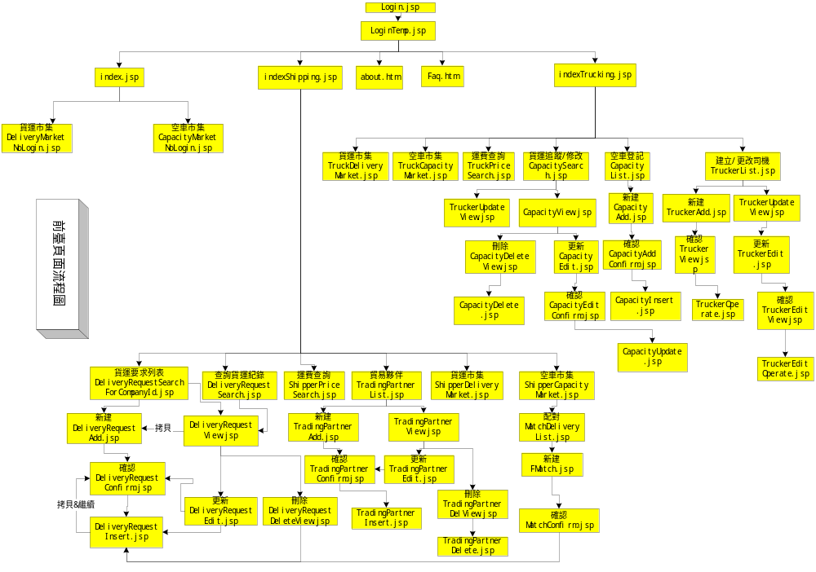

4.Backend structure

